Generating GPG:

gpg –gen-key

Now we export it to the GitHub repository, and we import all other keys from there.

For signing the key, we use the command –sign-key and then the start of an email of someone.

For example, here we signed Sandra’s key, my name sign appears also here.

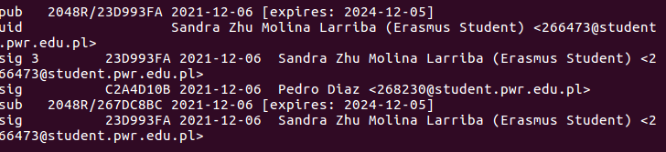
And of course, also yours.
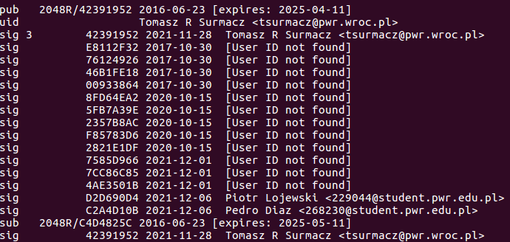
Now we will encrypt a message for you

